Inspired by Ben Schmidt’s [analysis of trends in the number of humanities majors](http://sappingattention.blogspot.com/2018/07/mea-culpa-there-is-crisis-in-humanities.html), I took a look at patterns in the number of sociology and other social science majors over the last 30 years.

The analysis is based on the number of majors reported by colleges and universities to the Department of Education, made available through the National Center for Education Statistics’s [IPEDS](https://nces.ed.gov/ipeds/) data system. I restrict my analysis to four-year degrees granted from BA, MA, and PhD granting institutions, excluding associate’s colleges and specialized institutions. The analysis includes 1,443 institutions.

*Caveat: I’ve never used this data before, so the analysis might be wrong. Also, the trends I get a similar, but not identical to the ones reported by Ben when are numbers overlap. That might be because we are studying slightly different populations. I’ve made available the data and my code.*

Here are my takeaways on the trends:

1. After 25 years of growth, the number of sociology majors nationwide peaked in peaked in 2013 at 36,014 majors. As of the most recent data, the preliminary 2017 report, we are down 11% from this peak.

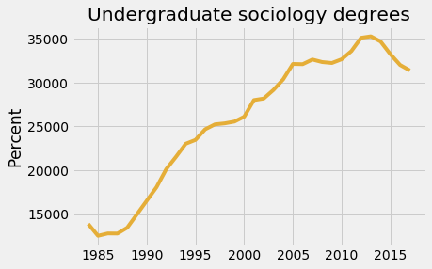

1. Things are much worse when you look at sociology degrees as a percentage of all degrees. We are down from 2.2% of all majors 2005 to 1.7% of majors in 2017. This is a decrease of 25%.

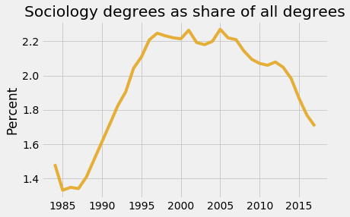

1. Things are much worse in political science. They are down 40% from their peak. In contrast, economics is rising, passing sociology in 2015 and political science in 2017. They aren’t back to their late 1980s heyday, but are up a third since 2000.

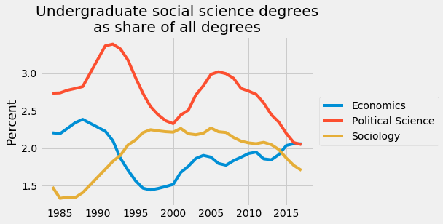

1. While trends for male and female majors for economics and political science have been relatively stable, the same is not true for political science, where men have left at higher rates than woman.

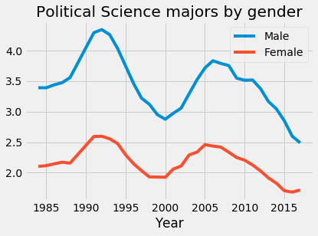

1. Looking more broadly at the social sciences, the numbers are fairly stable, over the past decades, as psychology has held its own and criminology (which includes criminal justice majors), have expanded. That said, things have ticked down over the last few years, which might be cause for concern.

